# CS 305 Module Five Coding Assignment Checksum Verification Template

## Instructions

Using the instructions from theModule Five Coding Assignment Checksum Verification Guidelines and Rubric, replace the bracketed text with the relevant information in your own words.

## Algorithm Cipher

Due to its low chance of collision, my recommendation will be SHA-256

## Justification

The reason I am recommending SHA-256 since it is one of the strongest hash functions. Due to its one way process it will not compromise in any possible way, that said SHA-256 does produce 256 bits digest, by doing so it is considered one of the best encryption algorithm ciphers. This algorithm makes it impossible for hackers to manipulate. SHA-256 is composed of a combination of numbers and letter ensuring that repetition of hash values being repeated.

## Generate Checksum

@RestController

**class** ServerController{

**public** **static** String calculateHash(String name) **throws** NoSuchAlgorithmException {

MessageDigest md = MessageDigest.getInstance("SHA-256");

**byte**[] hash = md.digest(name.getBytes(StandardCharsets.UTF_8));

BigInteger number = **new** BigInteger(1, hash);

StringBuilder hexString = **new** StringBuilder(number.toString(16));

**while** (hexString.length() < 32){

hexString.insert(0, '0');

}

**return** hexString.toString();

}

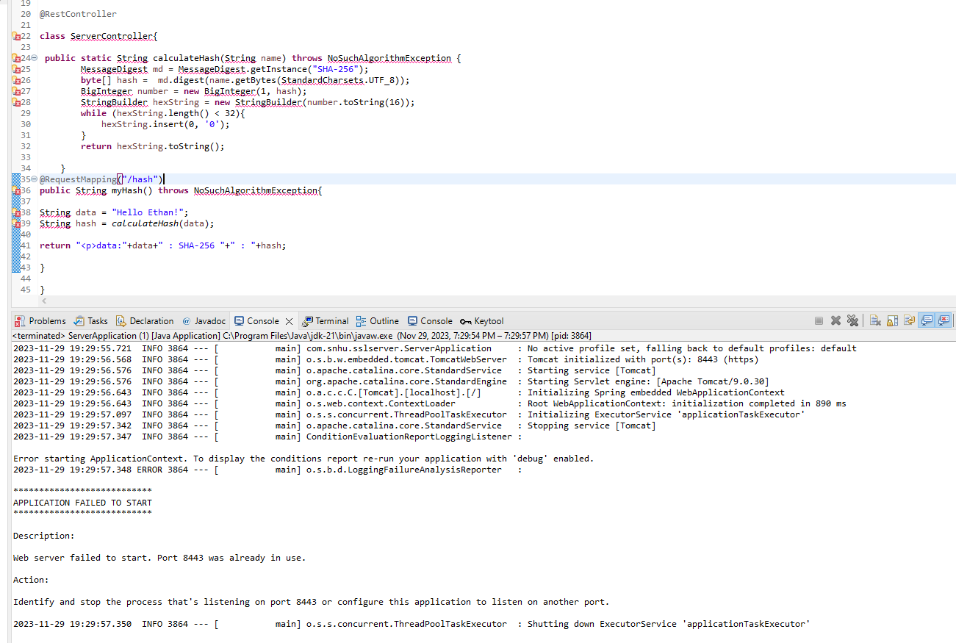

## Verification

I encounter issues generating my code I was unsuccessful that is why I am attaching the screen shot to provide my results